Introduction

**Problem Definition**

In today's gaming world, there are thousands of games created every year, across platforms and genres. Unfortunately, the majority of platforms do not offer a practical way for users to filter or search for suitable games. The current state confuses the user or fails to provide a good and easy way to browse meaningfully. Whether it's browsing by genre, popularity, release date, or developer, many users fail to browse through the games world appropriately and there is no place for gamers to talk about games. As a results people cannot search for games properly and cannot talk about their games.

**Objective of the Project**

The goal of this project is GameBox. GameBox is a game library created in a React with an aesthetic, simple and easy to use UI. Users can filter by genre, sort by popularity or release date, and pages of results render in front of their eyes for easy access to game discovery. They will be able to join the communities they want, talk about the games they want and see the games being talked about. This project aims to enhance the user's experience for game discovery across functionality, performance, and simplicity.

TECHNOLOGIES

Frontend: React,javascript,Html,css

Backend: Node.js with express.js

Database: Supabase(based PostreSQL)

Game Database: RAWG Video Games API

Version Control**:** GitHub

Hosting: Google cloud for backend, Firebase for frontend

SOFTWARE ARCHITECTURE

**Frontend:** Communicates with both external API and backend with Axios. React Router is used for navigation beetween pages.

**Backend:** Handles requests for favorite games, stores user actions or gets the game the user looking for ,handles user auth, handles session creation and more and acts as a proxy when developing.

**Database:** Stores user information, favorite games, and any custom collections.

ER DIAGRAM OF DATABASE

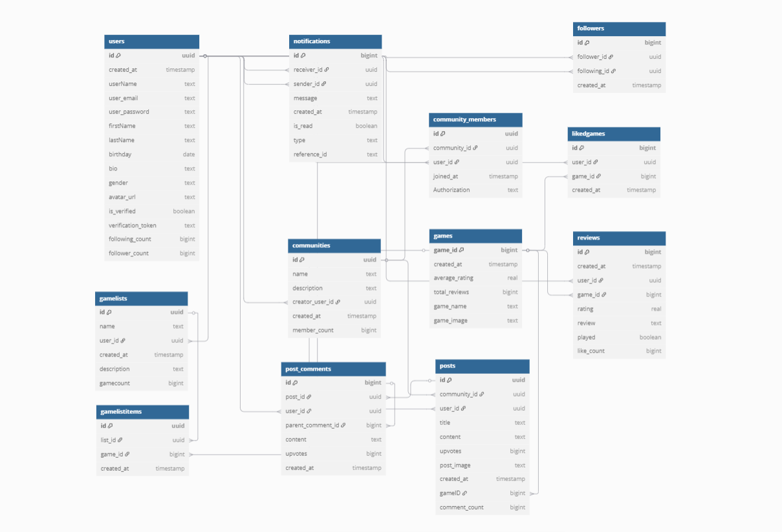

TABLE STRUCTURES

1.USERS

| **Column** | **Type** | **Constraints** | **Description** |
| --- | --- | --- | --- |
| id | uuid | Primary Key, DEFAULT gen_random_uuid() | Unique user ID |
| created_at | timestamp with time zone | NOT NULL, DEFAULT now() | Account creation timestamp |
| userName | text | NOT NULL, UNIQUE | Username |
| user_email | text | NOT NULL, UNIQUE | User email |
| user_password | text | NOT NULL | Hashed password |
| firstName | text | NULL | User's first name |
| lastName | text | NULL | User's last name |
| birthday | date | NULL | User's birthday |
| bio | text | NULL | User biography |
| gender | text | NULL | Gender |
| avatar_url | text | NULL | Profile picture URL |
| is_verified | boolean | NOT NULL, DEFAULT false | Verification status |
| verification_token | text | NULL | Token for verification |
| following_count | bigint | NULL, DEFAULT 0 | Number of users followed |
| follower_count | bigint | NULL, DEFAULT 0 | Number of followers |

2. Communities

| **Column** | **Type** | **Constraints** | **Description** |
| --- | --- | --- | --- |
| id | uuid | Primary Key, DEFAULT gen_random_uuid() | Community unique ID |
| name | text | NOT NULL | Community name |
| description | text | NULL | Community description |
| creator_user_id | uuid | NOT NULL, Foreign Key → Users(id) ON UPDATE CASCADE ON DELETE SET NULL | Creator's user ID |
| created_at | timestamp with time zone | NOT NULL, DEFAULT now() | Creation timestamp |
| member_count | bigint | NOT NULL, DEFAULT 0 | Number of members |

3. Community_Members

| **Column** | **Type** | **Constraints** | **Description** |
| --- | --- | --- | --- |
| id | uuid | Primary Key, DEFAULT gen_random_uuid() | Unique ID for membership |
| community_id | uuid | NOT NULL, Foreign Key → Communities(id) ON UPDATE CASCADE ON DELETE CASCADE | Community ID |
| user_id | uuid | NOT NULL, Foreign Key → Users(id) ON UPDATE CASCADE ON DELETE CASCADE | Member user ID |
| joined_at | timestamp with time zone | NOT NULL, DEFAULT now() | Joining timestamp |
| Authorization | text | NOT NULL, DEFAULT 'Member' | Role in community |

**4. Followers**

| **Column** | **Type** | **Constraints** | **Description** |
| --- | --- | --- | --- |
| id | bigint | Primary Key, GENERATED BY DEFAULT AS IDENTITY | Unique follow relationship ID |
| follower_id | uuid | Foreign Key → Users(id) ON UPDATE CASCADE ON DELETE CASCADE | User who follows |
| following_id | uuid | NOT NULL, Foreign Key → Users(id) ON UPDATE CASCADE ON DELETE CASCADE | User being followed |
| created_at | timestamp with time zone | NOT NULL, DEFAULT now() | Follow timestamp |

5. GameLists

| **Column** | **Type** | **Constraints** | **Description** |
| --- | --- | --- | --- |
| id | uuid | Primary Key, DEFAULT gen_random_uuid() | Game list unique ID |
| name | text | NOT NULL | List name |
| user_id | uuid | NOT NULL, Foreign Key → Users(id) ON UPDATE CASCADE ON DELETE CASCADE | Owner user ID |
| created_at | timestamp with time zone | NOT NULL, DEFAULT now() | Creation timestamp |
| description | text | NULL | Description of the list |
| first_four_images | text[] | NULL | First 4 images for preview (array) |
| gamecount | bigint | NOT NULL, DEFAULT 0 | Number of games in list |

6. GameListItems

| **Column** | **Type** | **Constraints** | **Description** |
| --- | --- | --- | --- |
| id | uuid | Primary Key, DEFAULT gen_random_uuid() | Unique item ID |
| list_id | uuid | NOT NULL, Foreign Key → GameLists(id) ON UPDATE CASCADE ON DELETE CASCADE | Reference to list |
| game_id | bigint | NOT NULL, Foreign Key → Games(game_id) ON UPDATE CASCADE ON DELETE CASCADE | Game ID |
| created_at | timestamp with time zone | NOT NULL, DEFAULT now() | When item was added |

**7. Games**

| **Column** | **Type** | **Constraints** | **Description** |
| --- | --- | --- | --- |
| game_id | bigint | Primary Key | Unique game ID |
| created_at | timestamp with time zone | NOT NULL, DEFAULT now() | When game added |
| average_rating | real | NULL | Average user rating |
| total_reviews | bigint | NULL | Number of reviews |
| game_name | text | NULL | Game title |
| game_image | text | NULL | Game image URL |

**8. LikedGames**

| **Column** | **Type** | **Constraints** | **Description** |
| --- | --- | --- | --- |
| id | bigint | Primary Key, GENERATED BY DEFAULT AS IDENTITY | Unique like ID |
| user_id | uuid | Foreign Key → Users(id) ON UPDATE CASCADE ON DELETE CASCADE | User who liked game |
| game_id | bigint | Foreign Key → Games(game_id) ON UPDATE CASCADE ON DELETE CASCADE | Liked game |
| created_at | timestamp with time zone | NOT NULL, DEFAULT now() | When liked |

9. Notifications

| **Column** | **Type** | **Constraints** | **Description** |
| --- | --- | --- | --- |
| id | bigint | Primary Key, GENERATED BY DEFAULT AS IDENTITY | Notification ID |
| receiver_id | uuid | NOT NULL, Foreign Key → Users(id) ON UPDATE CASCADE ON DELETE CASCADE | Notification receiver |
| sender_id | uuid | NOT NULL, Foreign Key → Users(id) ON UPDATE RESTRICT ON DELETE CASCADE | Notification sender |
| message | text | NULL | Notification message |
| created_at | timestamp with time zone | NOT NULL, DEFAULT now() | Created timestamp |
| is_read | boolean | NOT NULL, DEFAULT false | Read status |
| type | text | NULL | Type of notification |
| reference_id | text | NULL | Reference to related entity |

**10. Posts**

| **Column** | **Type** | **Constraints** | **Description** |
| --- | --- | --- | --- |
| id | uuid | Primary Key, DEFAULT gen_random_uuid() | Post ID |
| community_id | uuid | NOT NULL, Foreign Key → Communities(id) ON UPDATE CASCADE ON DELETE CASCADE | Community post belongs to |
| user_id | uuid | NOT NULL, Foreign Key → Users(id) ON UPDATE CASCADE ON DELETE SET NULL | Post creator |
| title | text | NOT NULL | Post title |
| content | text | NOT NULL | Post content |
| upvotes | bigint | NULL, DEFAULT 0 | Number of upvotes |
| post_image | text | NULL | Image URL |
| created_at | timestamp with time zone | NOT NULL, DEFAULT now() | Created timestamp |
| gameID | bigint | NULL, Foreign Key → Games(game_id) ON UPDATE CASCADE | Associated game |
| comment_count | bigint | NULL, DEFAULT 0 | Number of comments |

**11. Post_Comments**

| **Column** | **Type** | **Constraints** | **Description** |
| --- | --- | --- | --- |
| id | bigint | Primary Key, GENERATED BY DEFAULT AS IDENTITY | Comment ID |
| post_id | uuid | NOT NULL, Foreign Key → Posts(id) ON UPDATE CASCADE ON DELETE CASCADE | Related post |
| user_id | uuid | NOT NULL, Foreign Key → Users(id) ON UPDATE CASCADE ON DELETE SET NULL | Commenter user |
| parent_comment_id | bigint | NULL, Foreign Key → Post_Comments(id) ON UPDATE CASCADE ON DELETE CASCADE | Parent comment (if reply) |
| content | text | NOT NULL | Comment content |
| upvotes | bigint | NULL, DEFAULT 0 | Number of upvotes |
| created_at | timestamp with time zone | NOT NULL, DEFAULT now() | Created timestamp |

**12. Reviews**

| **Column** | **Type** | **Constraints** | **Description** |
| --- | --- | --- | --- |
| id | bigint | Primary Key (composite with game_id), GENERATED BY DEFAULT AS IDENTITY | Review ID |
| created_at | timestamp with time zone | NOT NULL, DEFAULT now() | Review timestamp |
| user_id | uuid | NOT NULL, Foreign Key → Users(id) ON UPDATE CASCADE ON DELETE CASCADE | Reviewer |
| game_id | bigint | NOT NULL, Foreign Key → Games(game_id) ON UPDATE CASCADE ON DELETE CASCADE | Reviewed game |
| rating | real | NULL | Rating score |
| review | text | NULL | Review text |
| played | boolean | NULL | Played status |
| like_count | bigint | NULL, DEFAULT 0 | Number of likes |

13.lists_like

| **Column** | **Type** | **Constraints** | **Description** |
| --- | --- | --- | --- |
| id | uuid | PRIMARY KEY, DEFAULT gen_random_uuid() | Unique identifier for each like |
| list_id | uuid | FOREIGN KEY → GameLists(id) (CASCADE) | ID of the liked game list |
| user_id | uuid | FOREIGN KEY → Users(id) (CASCADE) | ID of the user who liked the list |
| created_at | timestamp with time zone | NOT NULL, DEFAULT now() | Timestamp of when the like was created |

14.reviews_like

| **Column** | **Type** | **Constraints** | **Description** |
| --- | --- | --- | --- |
| id | bigint | PRIMARY KEY, GENERATED BY DEFAULT AS IDENTITY, NOT NULL | Auto-incremented unique like ID |
| user_id | uuid | FOREIGN KEY → Users(id) (CASCADE) | ID of the user who liked the review |
| review_id | bigint | FOREIGN KEY → Reviews(id) (CASCADE) | ID of the liked review |
| created_at | timestamp with time zone | NOT NULL, DEFAULT now() | When the like was created |
| game_id | bigint | FOREIGN KEY → Games(game_id) (CASCADE) | Related game (optional) |

THE SYSTEM EXPLANATIONS

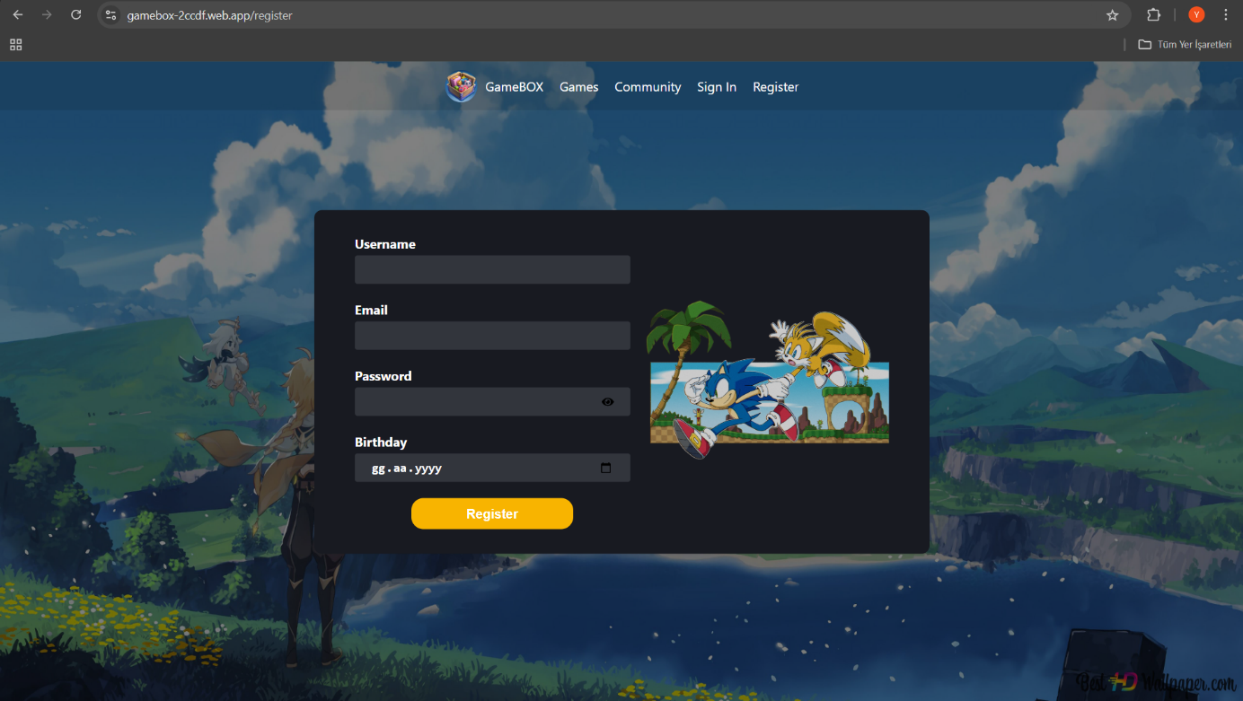

Figure 1

You can register on our site after entering the necessary information from Figure 1 then if everthing is correct system wants you to confirm your email. This actions will insert the data in the Users after confirmation isVerify in Users table will be true.

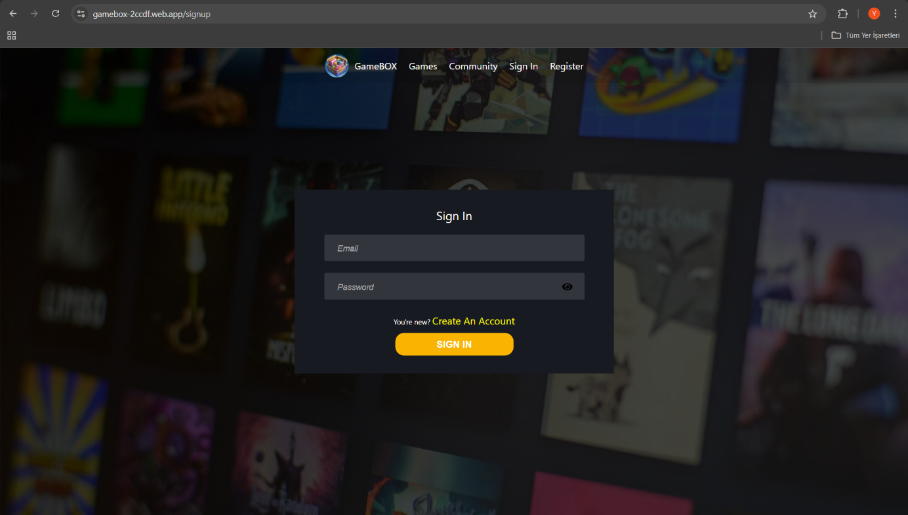

Figure 2

After registering and verifying your email, you can log in to the site by entering your email and password here and the system will create a session for the user, but you do not have to register to browse the site. You can look at the game or posts you want, but you cannot comment or like.

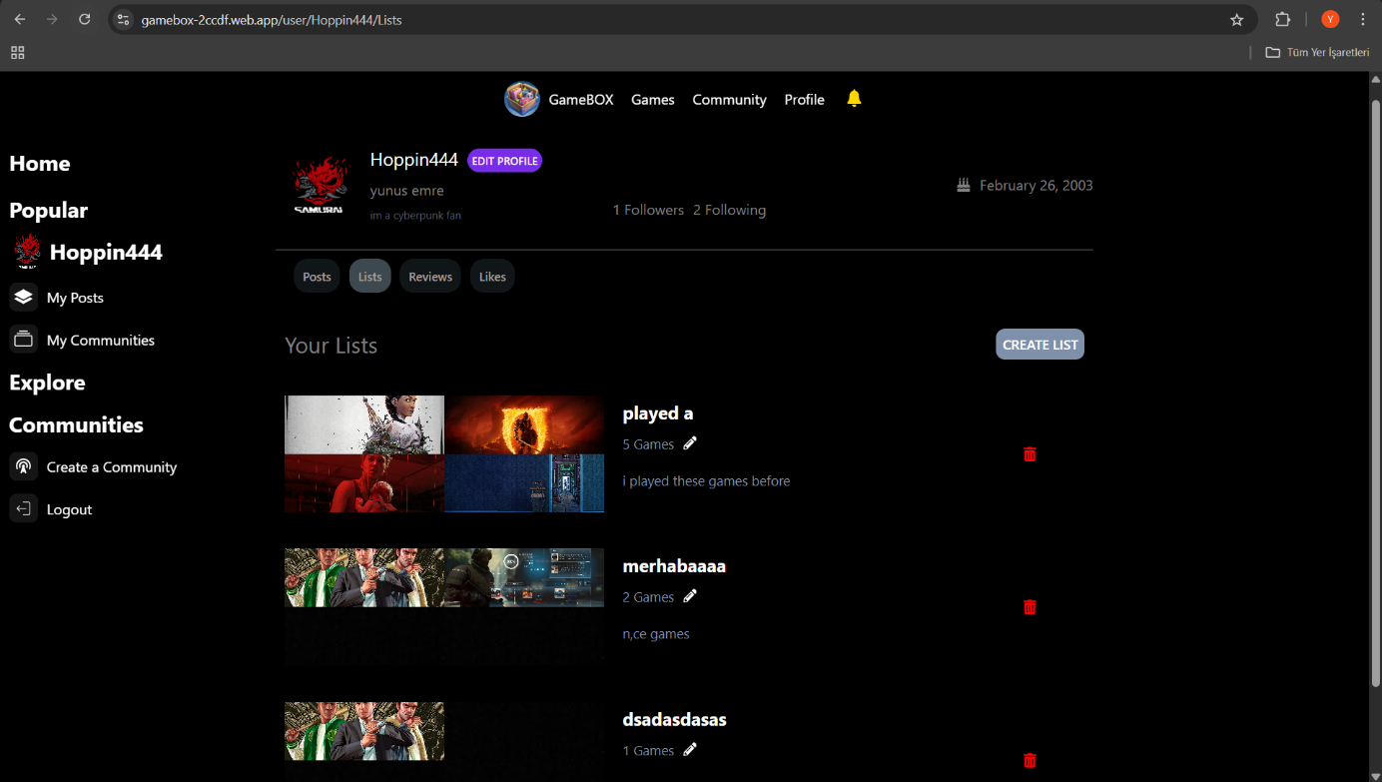

Figure 3

After logging in, the system directs you to the profile page(Figure 3). This page is where you can see, create or edit your lists and also enter your personal information.

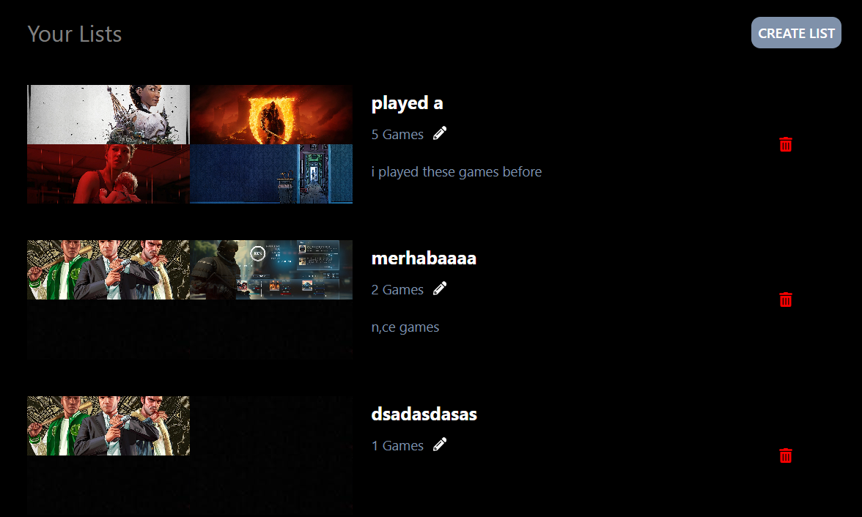

Figure 4

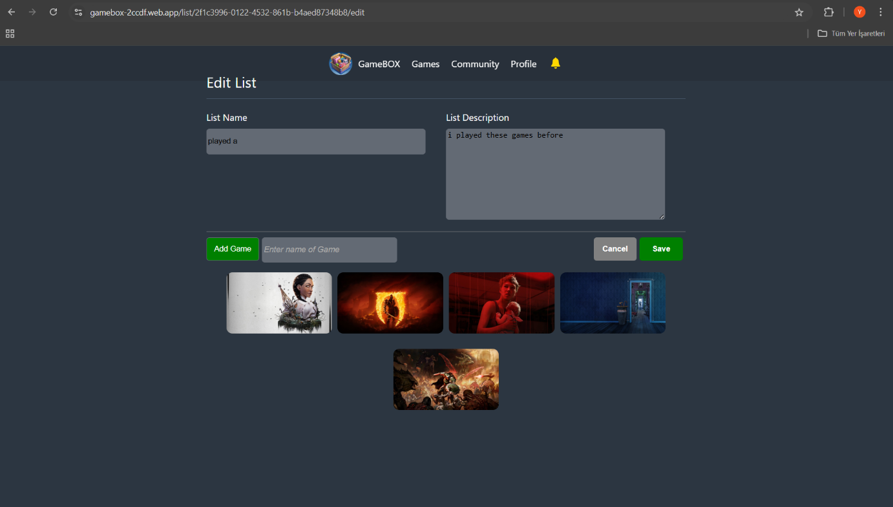

Figure 5

When you press the pencil button where the lists in Figure 4 appear, it directs you to Figure 5, where you can change the name of your list or add game to the list when you add game to the list it will insert the game data in the gameListItems based on listId.



Figure 6

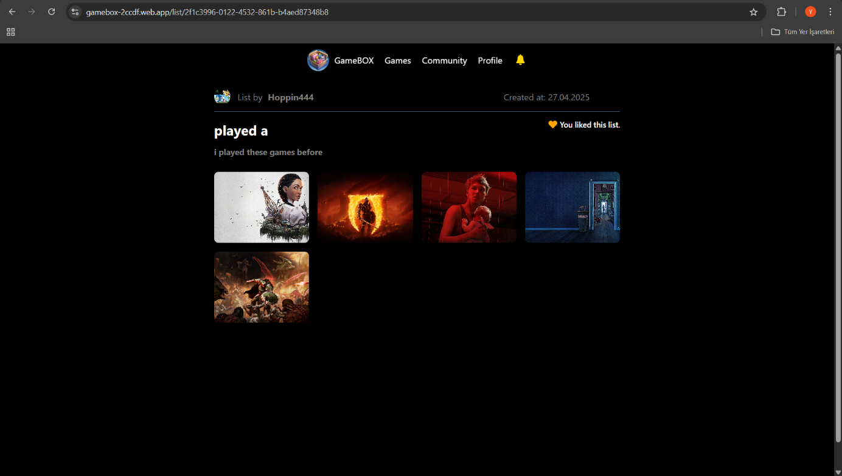

Figure 7

When you click on the place in Figure 6, where the 4 pictures are,it will lead to you Figure 7 where you can view the games in the list, the person who created the list, and you can like the list and look at it later. Anyone can view this list, but Figure 5 is only open to the user who created the list.

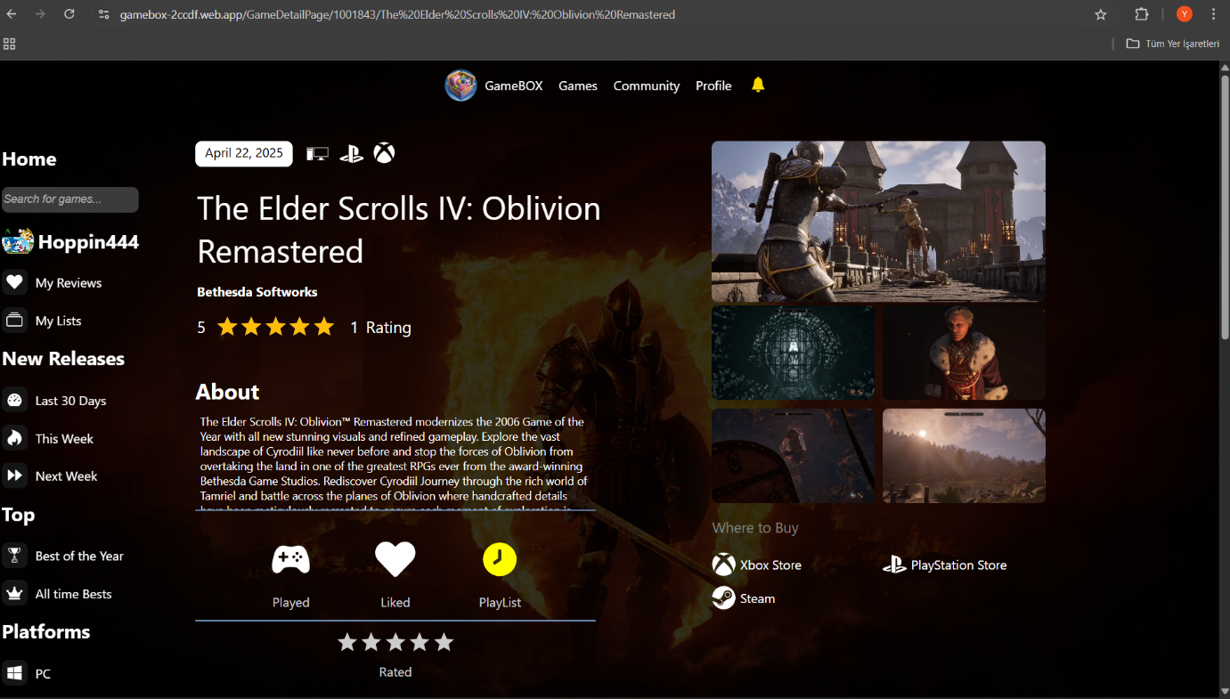

Figure 8

When you click on one of the games in Figure 7, the system will direct you to the game detailpage. On this page, you can see the details of the game, make comments or add it to another list.

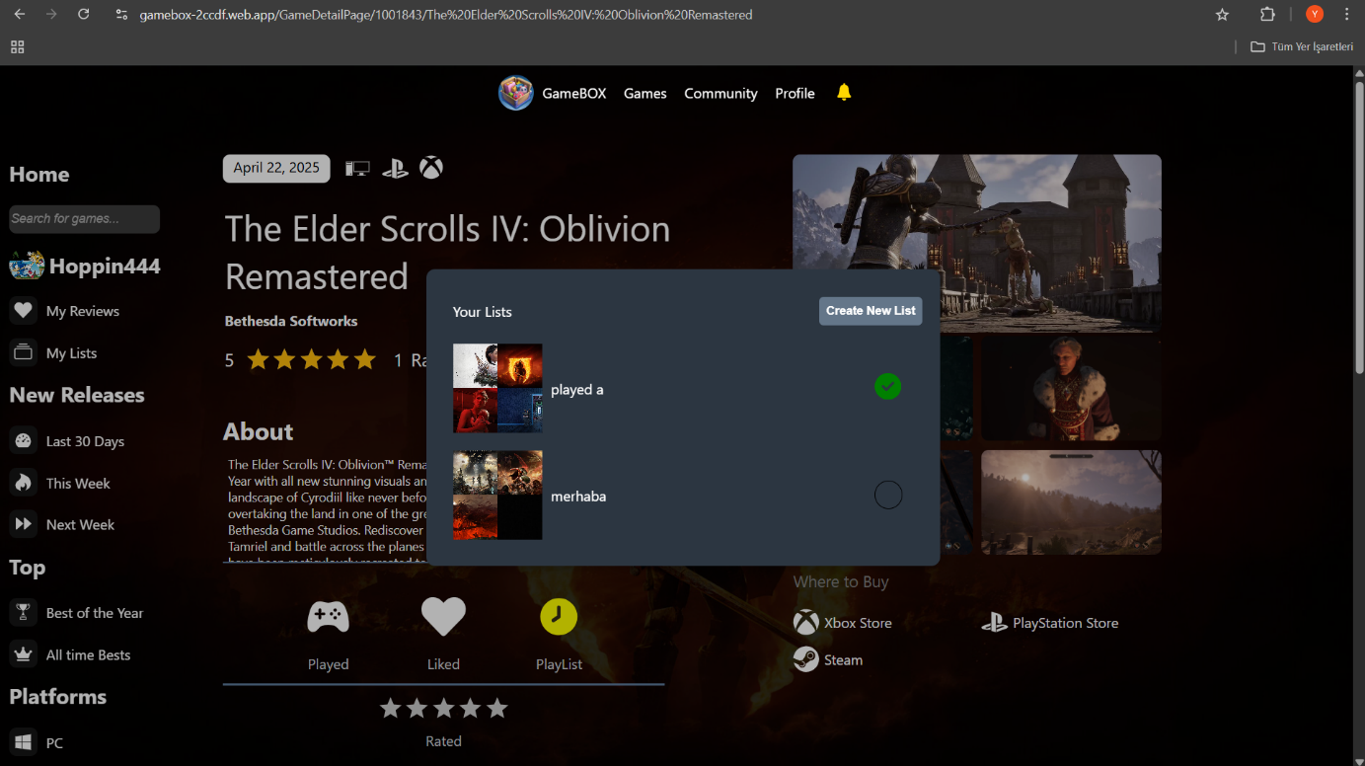

Figure 9

After clicking Playlist button in Figure 8 this modal will pop up and this will check if you have this game one of your list and from here you can add this game to lists and also you can create new list for the game with clicking the Create New List button .

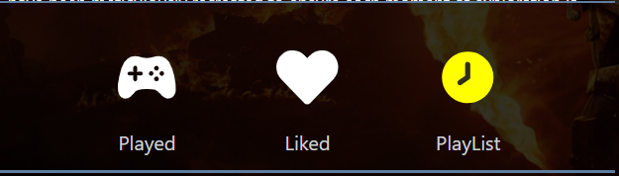 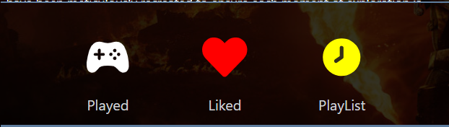

Figure 10 Figure 11

After clickling the liked button in Figure 10 system will insert data in LikedGames table based on userId and gameId.and also When the user clicks on any game, the system will check whether it liked the game or not. User will be able to view the games he/she liked.

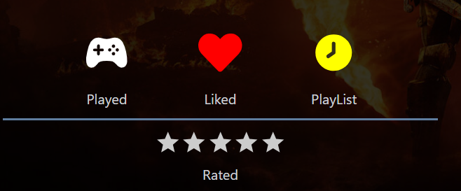

Figure 12

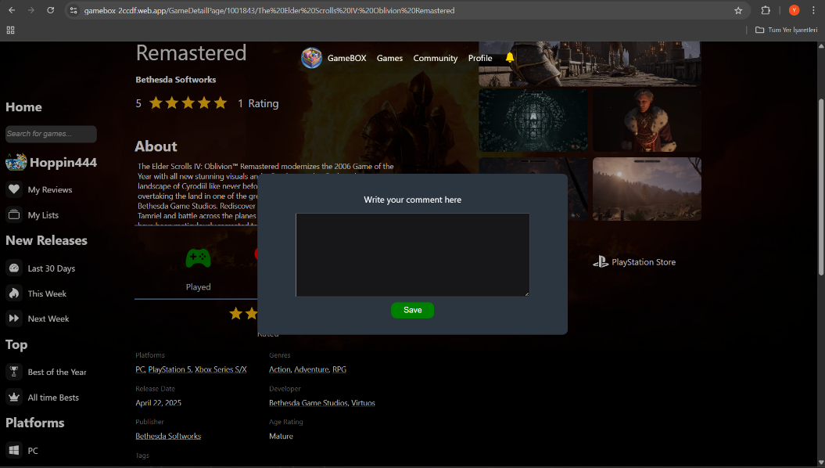

Figure 13

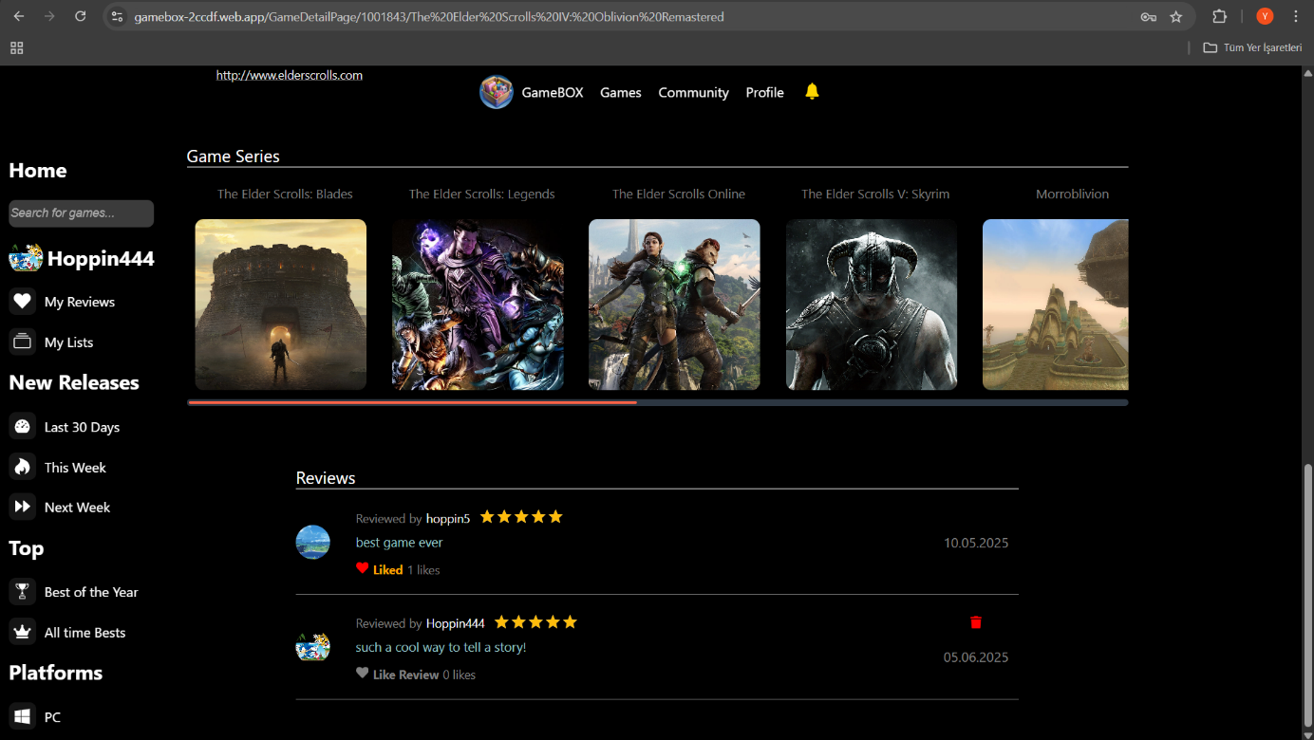

Figure 14

After rating the game in Figure 12 ,modal in Figure 13 will pop up and you can write your comment about the game in here After saving, it will appear in the review section in Figure 14. From here, we can delete our comment or like other comments . this action will insert the data such as your comment or your rating in Reviews table and the system will automatically calculate the average rating in database .

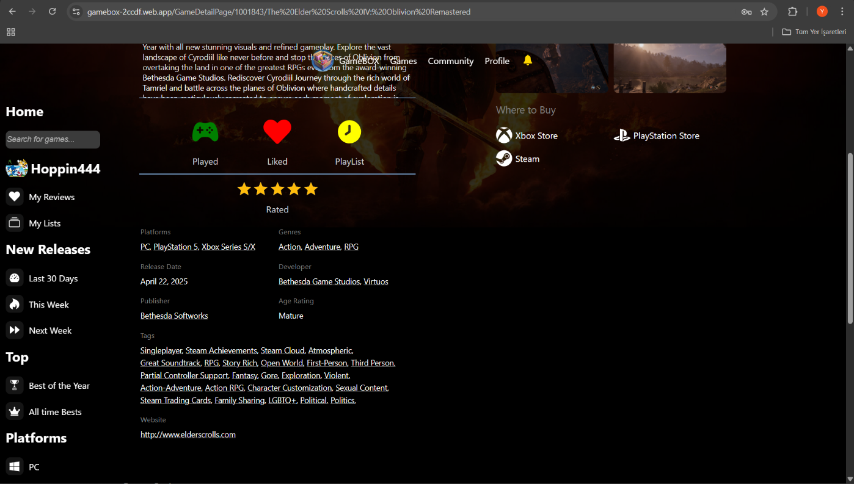

Figure 15

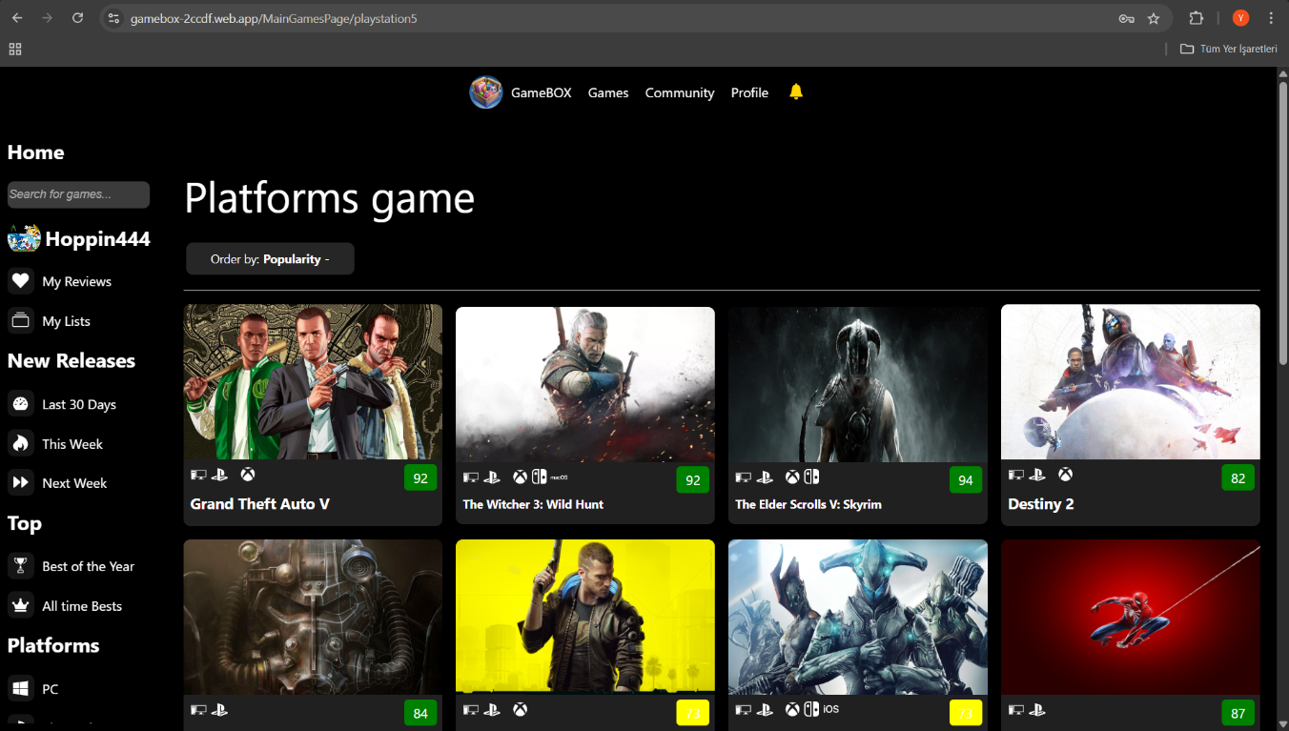

Figure 16

If we click on options like genre, platform, developer in Figure 15, the system shows us the games according to the filters we clicked on. For example, when we click on playstation 5, it shows us the games on playstation 5, as in Figure 16.

In figure 16, we can sort these games by popularity or name or release date as we wish. All we have to do is select the one we want from the order by option above the games.

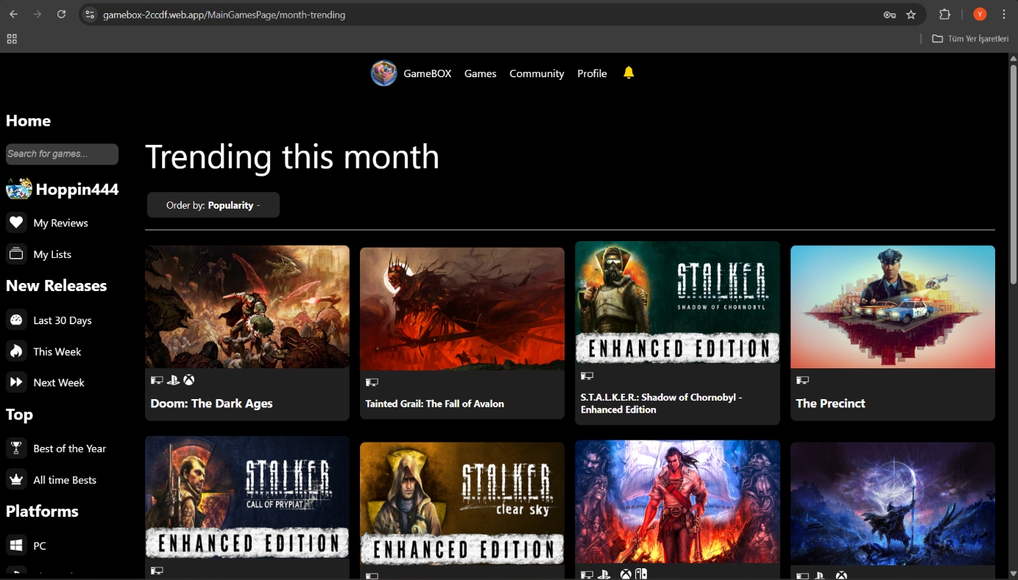

Figure 17

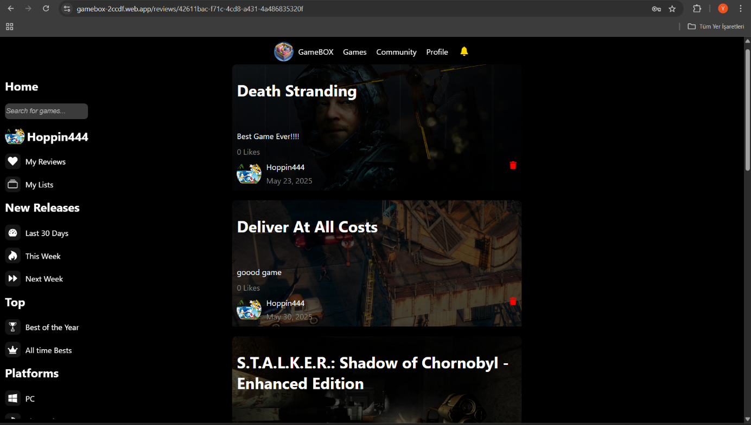

Figure 18

When you click on the Games button in the layout in the Figure 17 ,it takes you to the main page where recently relased games are shown.You can order them based on your choice too.and in the left Layout There are buttons that you can sort on your choice, such as games released this week. When you press this button, it shows the games released in the last week.or if you click My Reviews button it will take you to page(Figure 18) where all your reviews are shown.

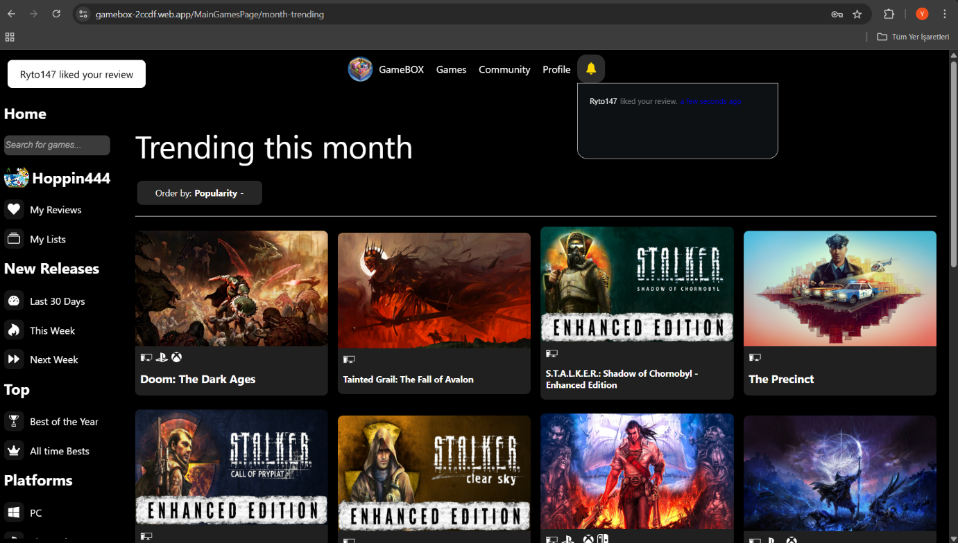

Figure 19

There is a notification service in our system ,when someone like your comment system inserts notification in Notifications table .there is a real-time connection with the database Notifications table based on userId, when someone likes your comment while you are browsing the site, you receive a notification.

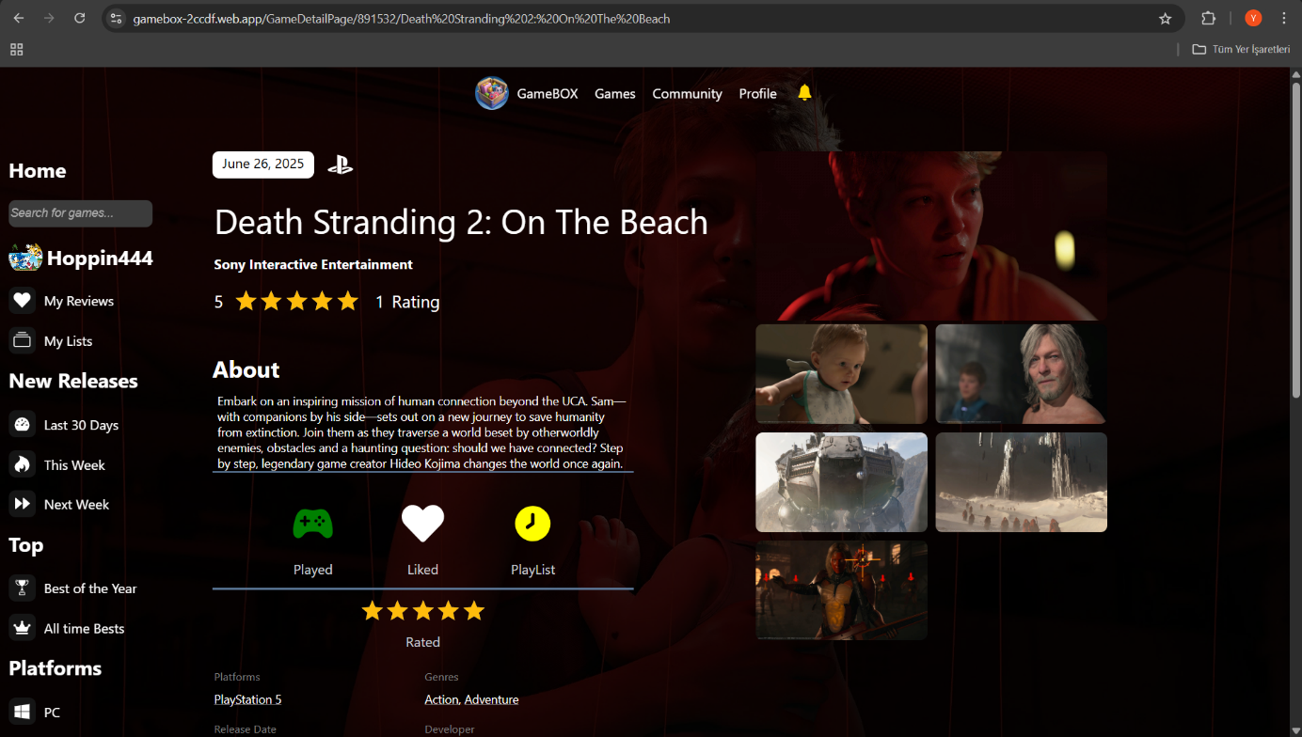

Figure 20

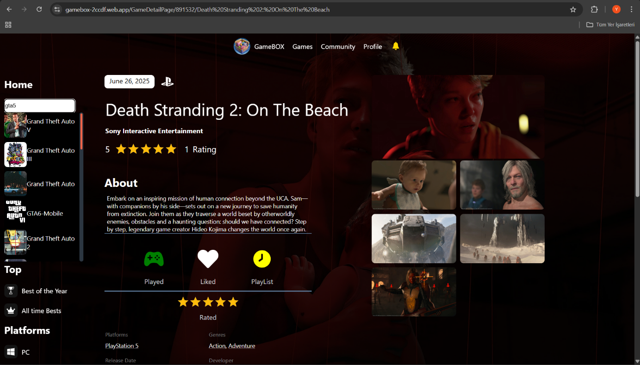

Figure 21

If user wants to search for specific game in the website he/she just need to click search button in the left layout in the Figure 20 and type the game name and system will send a request to backend for the search and the results will be shown like in Figure 21

Community Part

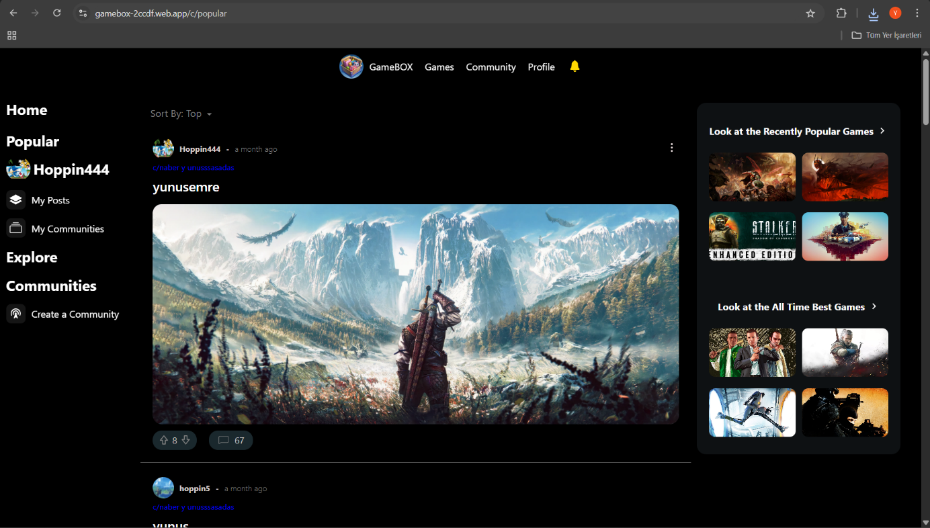

Figure 22

When we click on the community section in the layout in Figure 22, we can see the conversations and posts about the games or we can create or join a community and create our own post.

First lets start with how the create a community

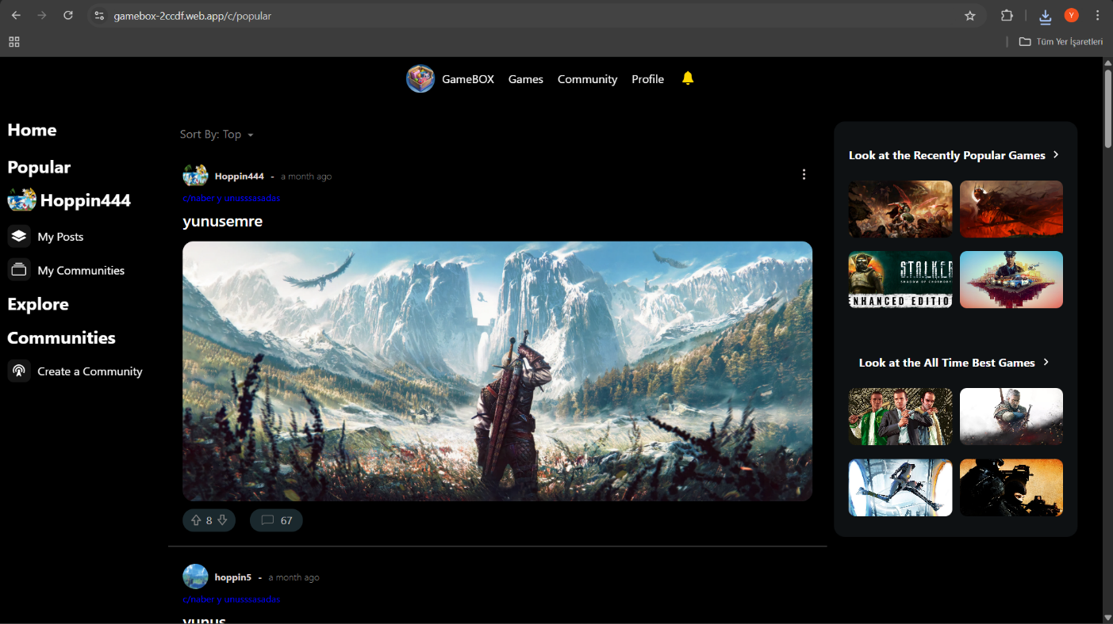

Figure 23

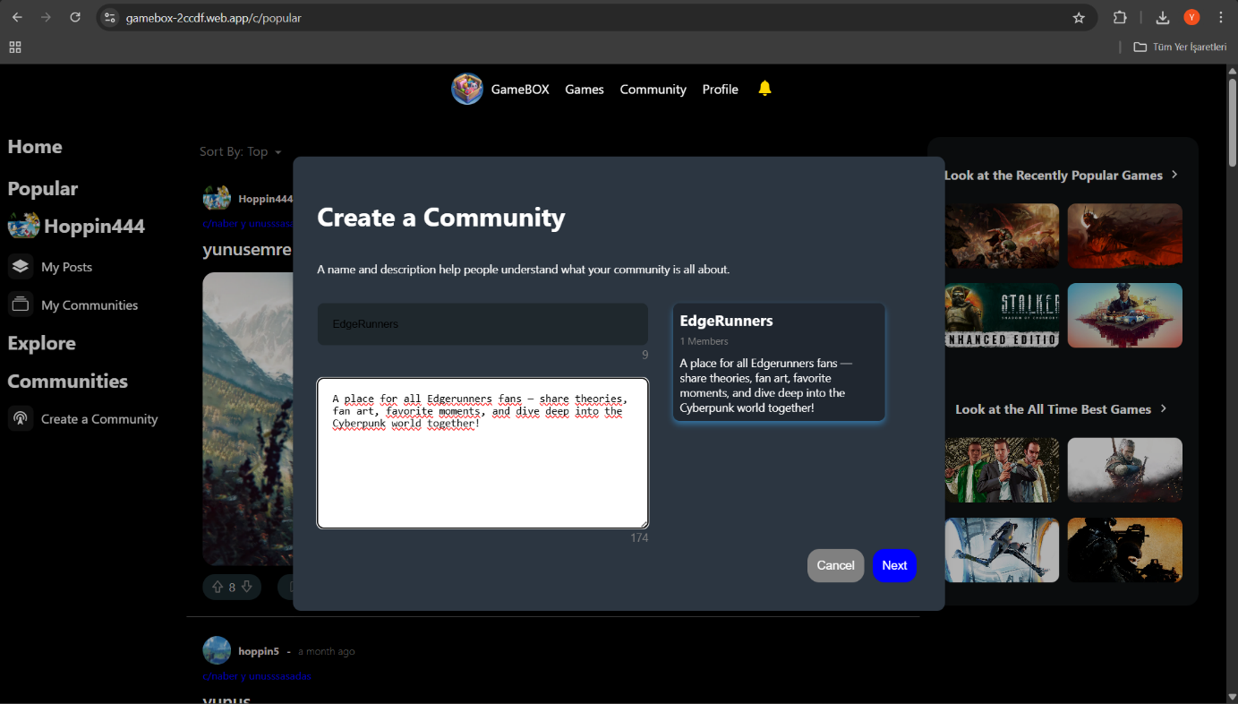

Figure 24

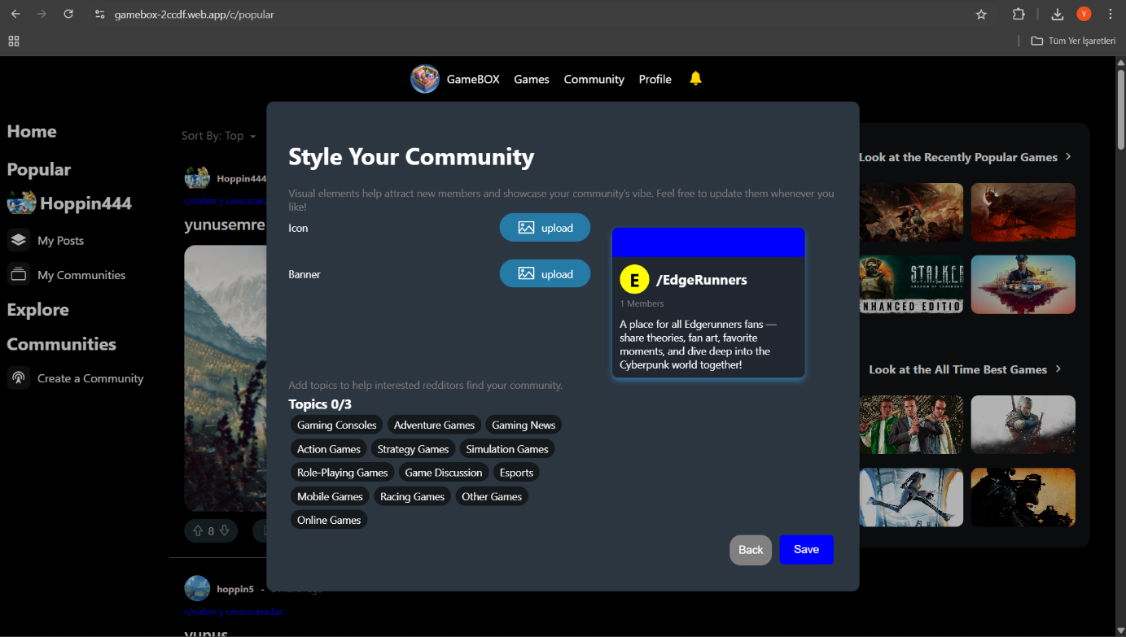

Figure 25

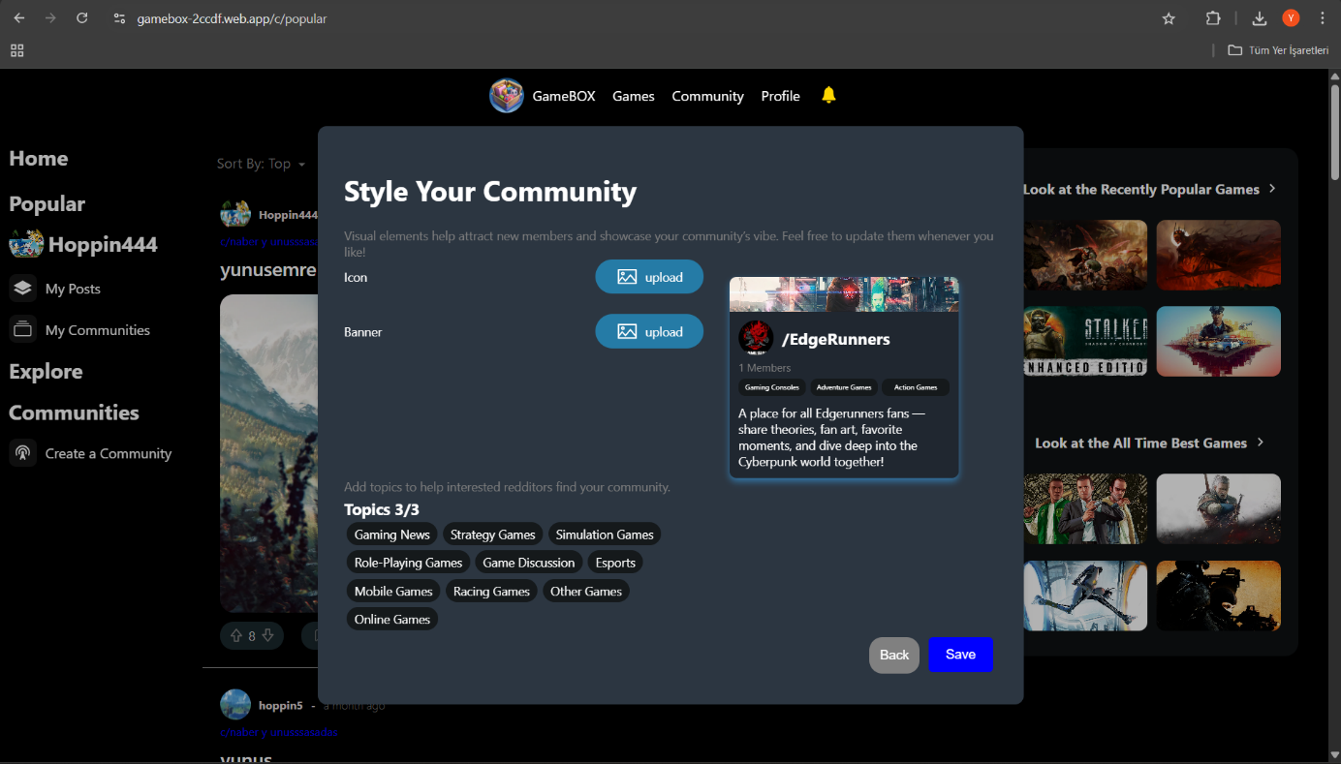

Figure 26

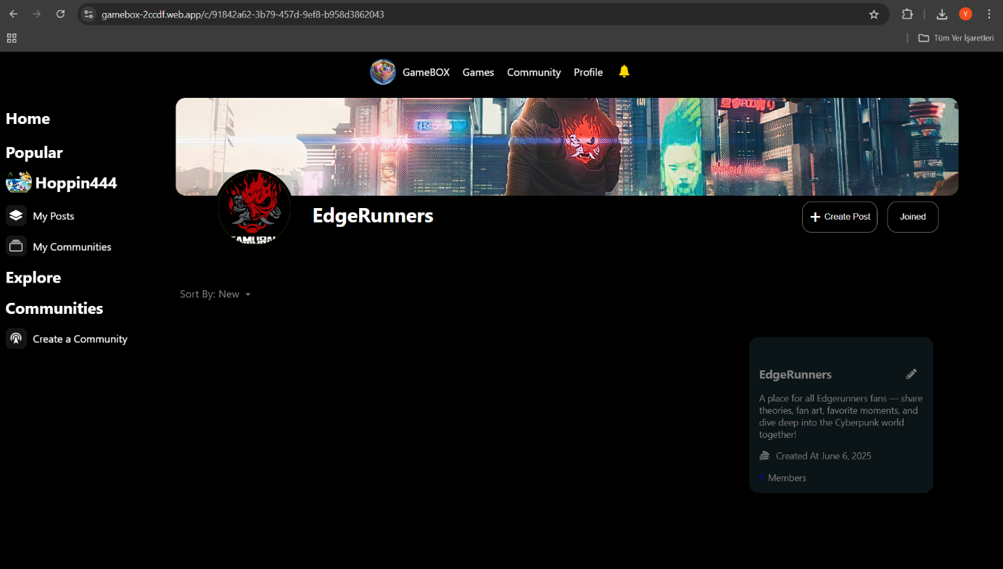

Figure 27

When we click on the create community button on the left layout in Figure 23, the modal in Figure 24 will appear. This is where we will enter the name and description of our community. After entering, we click on the next button. The page in Figure 25 will be shown. Then we can load the icon and banner of our community as we wish. If we load it, it will look like in Figure 26. When we click save, the system sends a request to the backend and backend inserts this information into the Community table in the database.after saving the system will take you to the community main page in Figure 27 where your community information are shown.in here you can create post by pressing the Create Post shown in Figure 27.

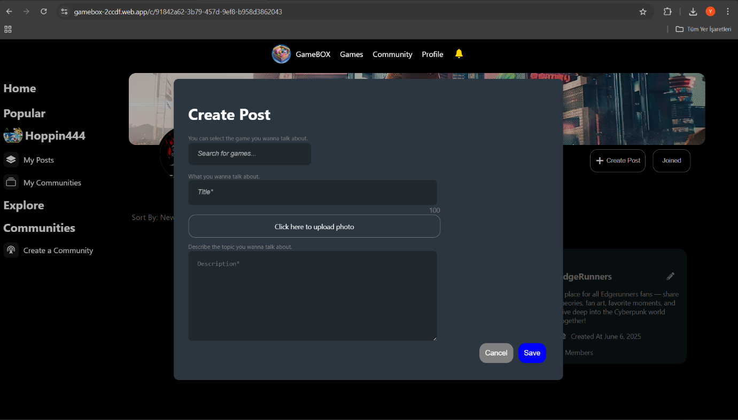

Figure 28

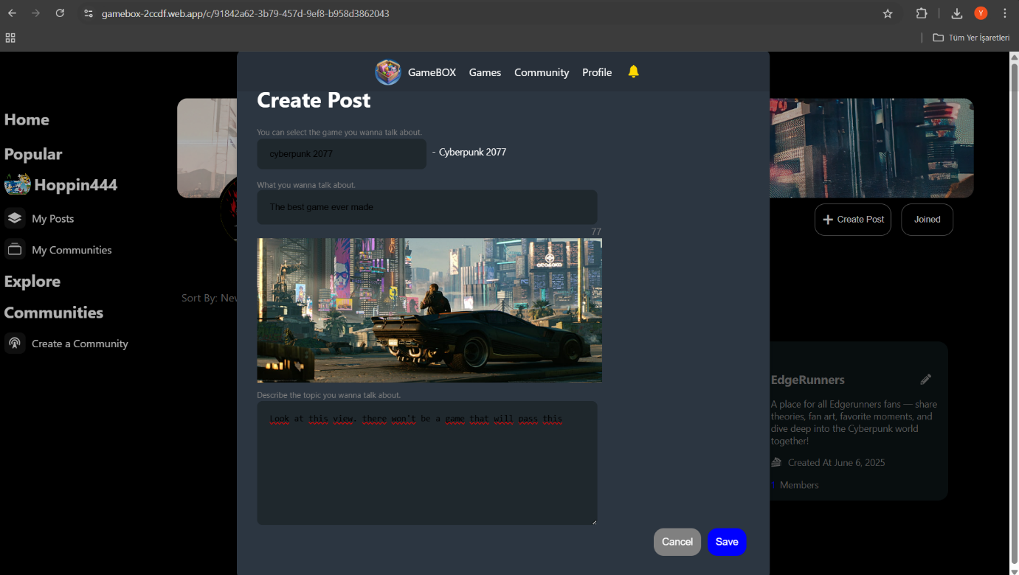

Figure 29

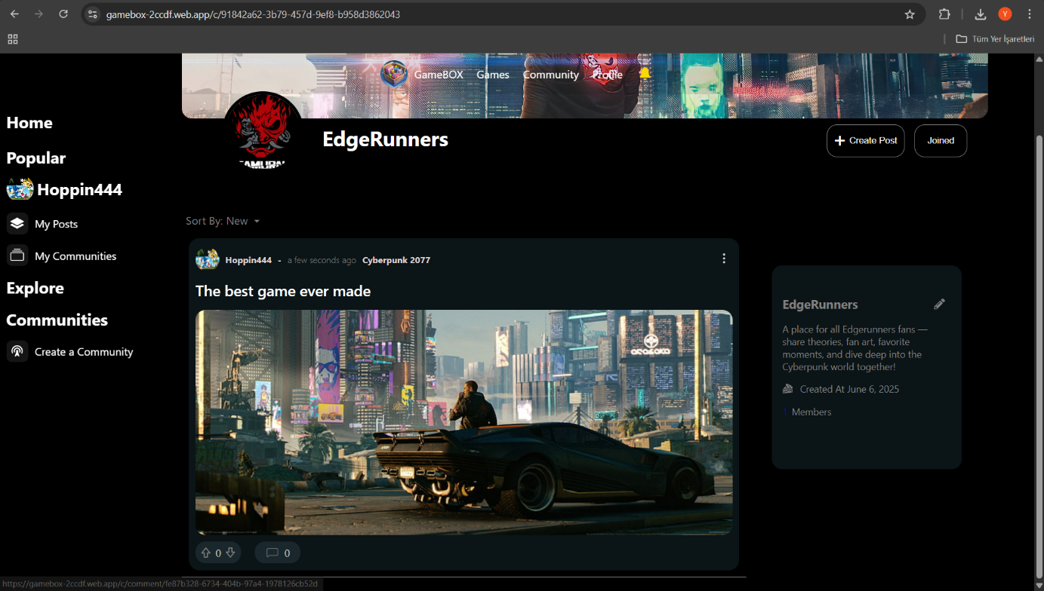

Figure 30

After clicking the create button in Figure 27 a modal will pop up like in Figure 28.then you will type neccesary information such as title or the game you wanna talk about and if you wanna add a photo, you can add by clicking the upload photo part.After adding everthing it will look like in the Figure 29.After clicking the Save button in the bottom of Figure 29 the data will insert in Posts table based on the communityId.and your post will appear on the page of the community you created it in like in the Figure 30.And you can sort the all posts that have made in that community by selecting the sort type from the red part of Figure 30.

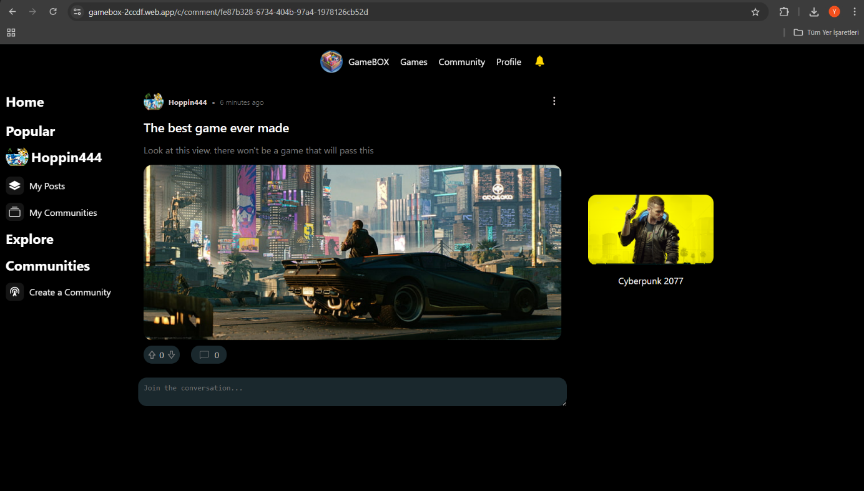

Figure 31

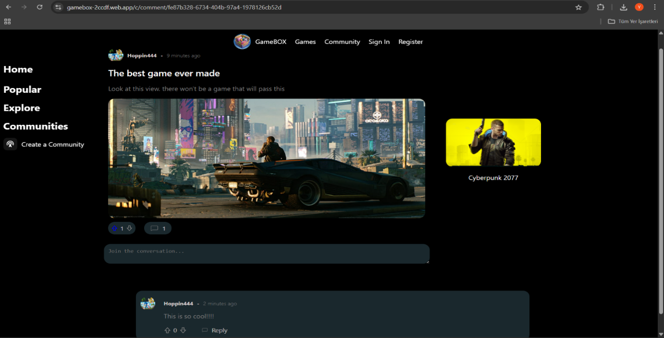

Figure 32

If you click on a post it will take you to the part where the comments of the post will appear like in the Figure 31. and you can comment here ,when you comment system sends request to the backend and backend sends the data to database where you comment will be stored in the Post_comments Table then your comment will appear like in the Figure 32 and you can like the post or like other comments or click on the game and go to a page in Figure 8 where you can see the details of the game.

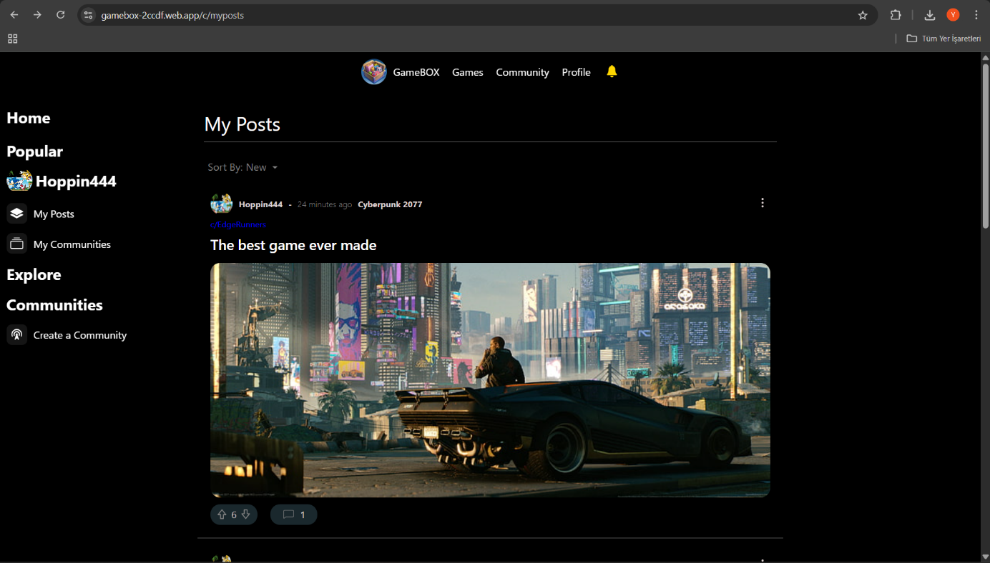

Figure 33

When you click on the My Posts section shown in Figure 33, you can see all the posts you have created and sort them by the date you created or by the most votes.

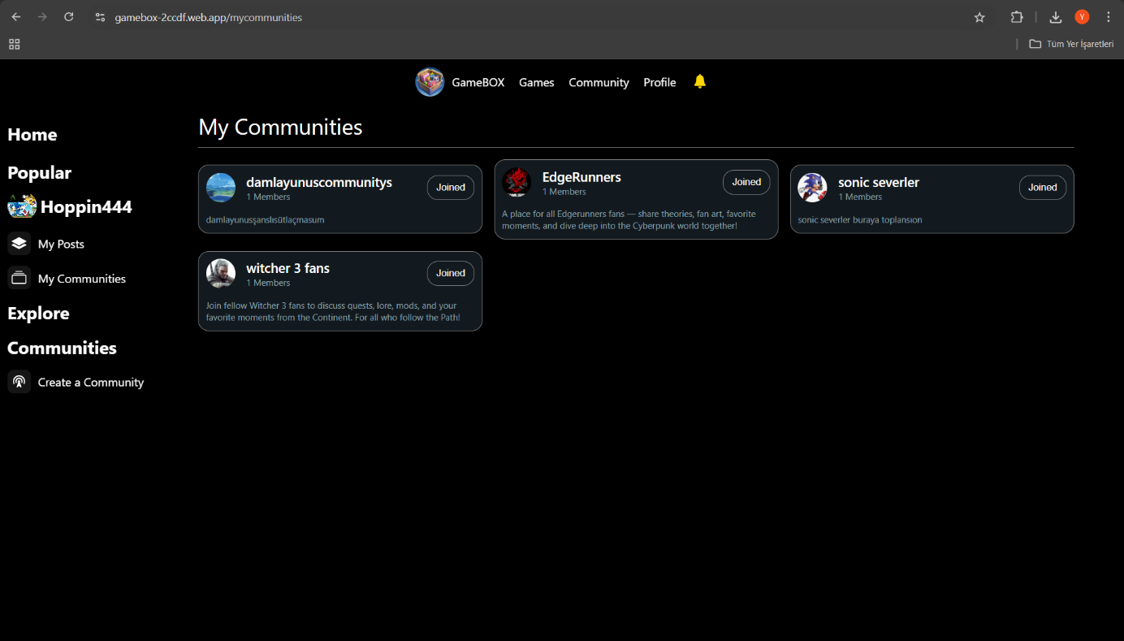

Figure 34

When you click on the My Communities section shown in Figure 34, you will see the communities that you have joined .You can click on them to see the posts and information of the Community a screen like Figure 27 will appear.

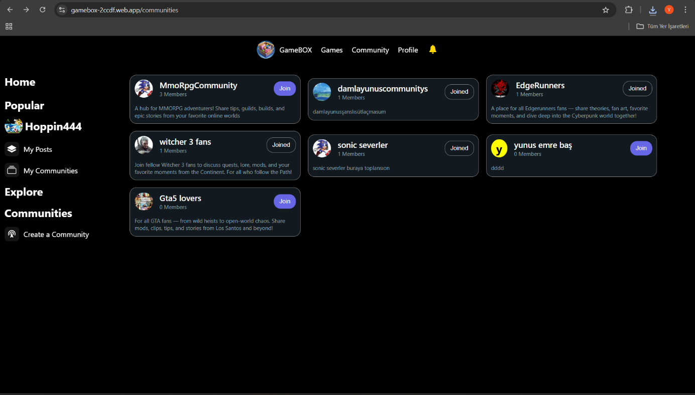

Figure 35

When you click on the My Communities section shown in Figure 35,you will see the all communities that you can join or leave. You can click on them to see the posts and information of the Community a screen like Figure 27 will appear.

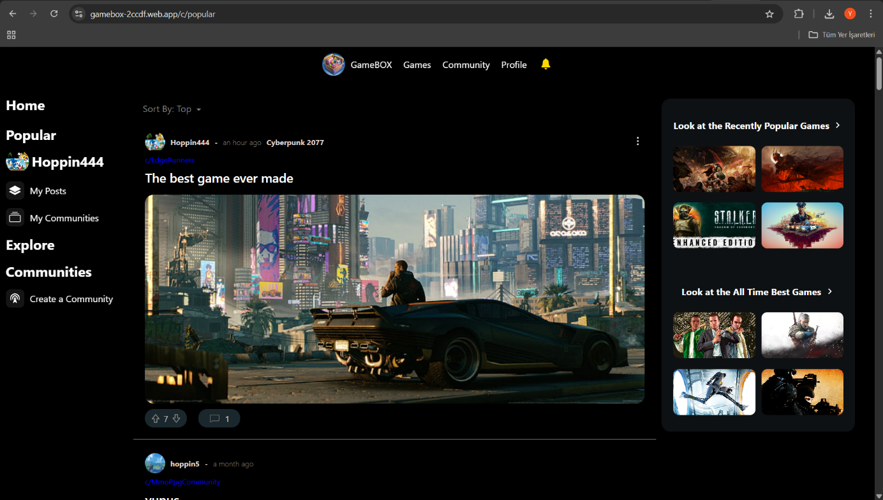

Figure 36

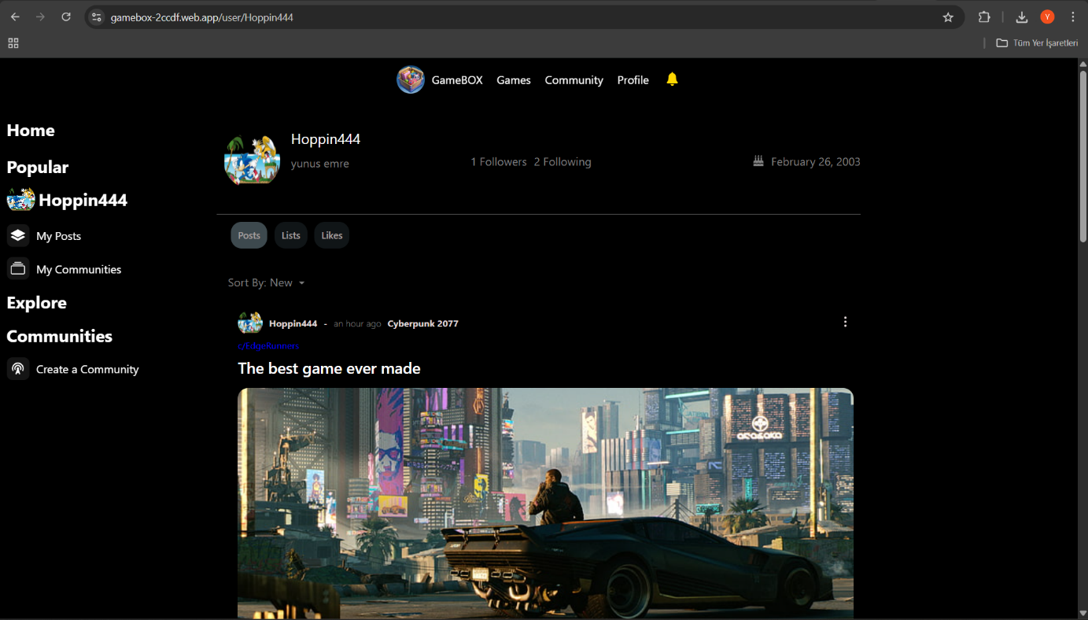

Figure 37

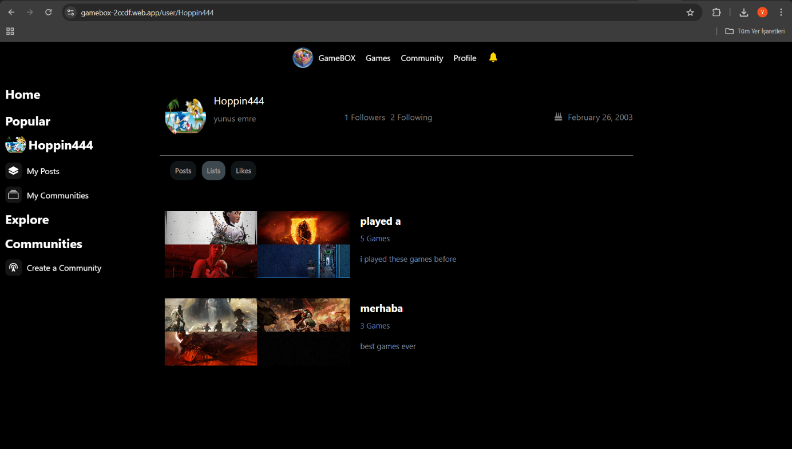

Figure 38

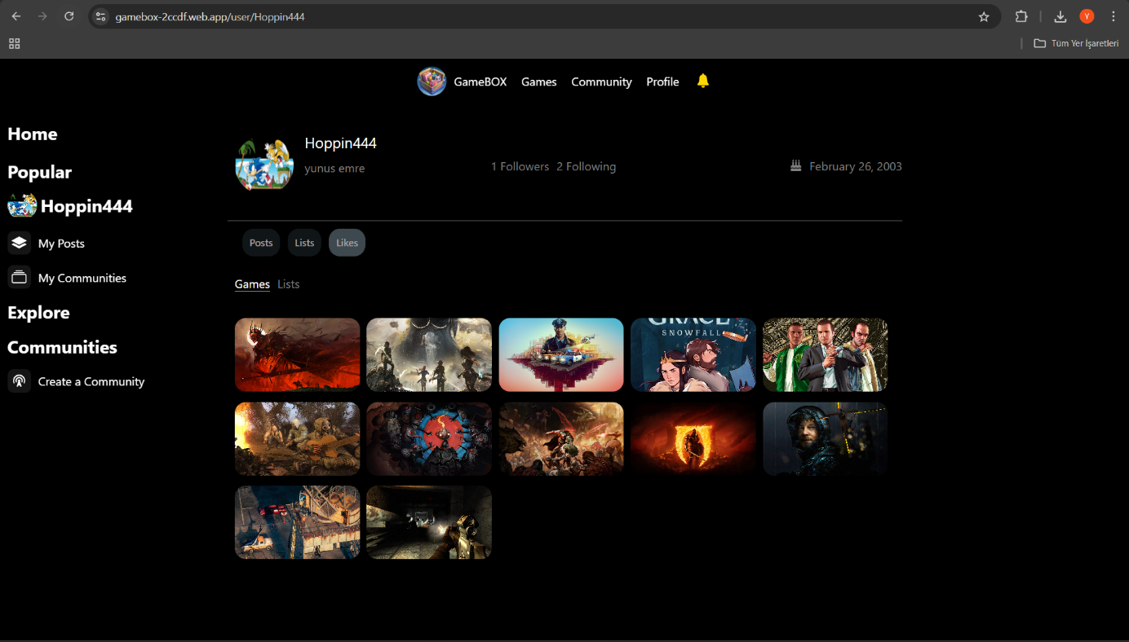

Figure 39

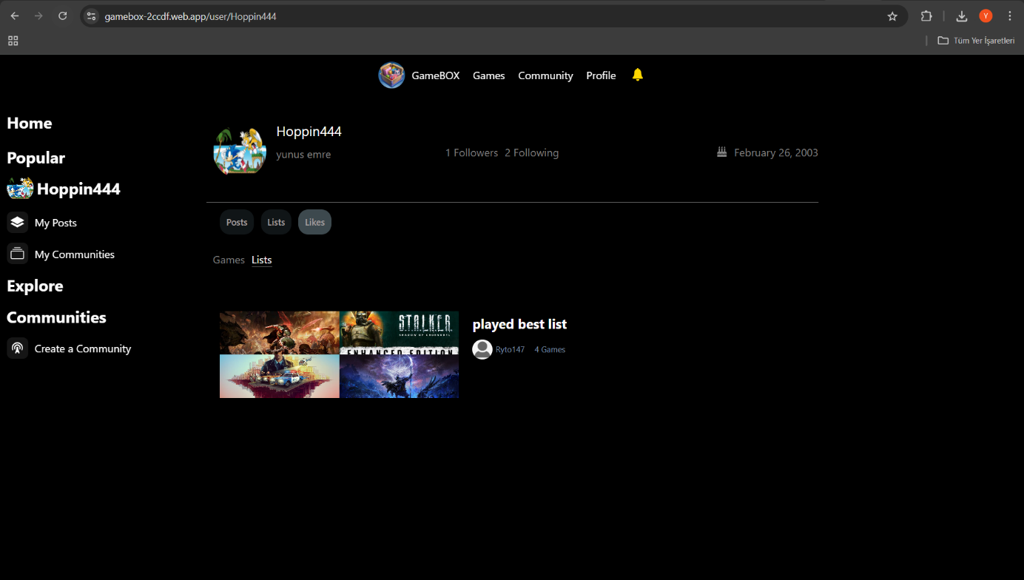

Figure 40

When you click on a post as in Figure 36, it will direct you to a page like in Figure 37, and on this page you will be able to see the lists of games the user liked or the posts he/she have created as shown in figure Figure 37,Figure 38,Figure 39,Figure 40

Conclusion

This was the project GameBox, a game library application created in React. The purpose was to build an easy access platform by which users can search for games via genre, popularity, release date, easily find paginated entries, find the games they look for and make list to share with others.

This application boasts not only proper functionality and performance considerations but also ensuring that the user experience remains smooth and good. and the community features allow users to post opinions and topics while the opportunity exists to look on trending games based on community advice.

This project allowed us to improve our skills in full-stack development, UI/UX design, and collaborative teamwork. İn the future ,We plan to expand GameBox with more advanced features such as personalized recommendations,and more real time community-interactions.

**References**

1. GameBox

<https://gamebox-2ccdf.web.app>

1. GameBox github repositories

<https://github.com/Hoppin4/movieBOX>

1. GameBox presentation video

<https://drive.google.com/drive/folders/1AKo8W8S4cuq93SN_PllCvZEhdThVJc72?usp=drive_link>

1. RAWG Video Games Database API Documentation.  
   [*https://rawg.io/apidocs*](https://rawg.io/apidocs)
2. React   
   [*https://reactjs.org/*](https://reactjs.org/)
3. React Router Documentation.  
   [*https://reactrouter.com/en/main/start/tutorial*](https://reactrouter.com/en/main/start/tutorial)
4. Axios – For sending request to backend or database   
   [*https://axios-http.com/docs/intro*](https://axios-http.com/docs/intro)
5. Figma – For design  
   [*https://www.figma.com/*](https://www.figma.com/)

6.React-icons -

<https://react-icons.github.io/react-icons/icons/bs/>

7.Supabase – For storing data

<https://supabase.com/docs>